
P R E S S R E L E A S E

WORKHOLDING STABILISER SYSTEM TO BE LAUNCHED IN EUROPE AT EMO 2023

US firm Blue Photon (www.bluephotongrip.com) has designed a new, photo-activated adhesive workholding system comprising patented grippers and inserts, intended for use with stabiliser systems marketed by Big Daishowa and others that add extra rigidity to tall components while they are being machined.

The Workholding Stabilizer System will be launched in Europe at the EMO 2023 trade fair in Hannover, 18th - 23rd September, on the Blue Photon stand, B84 in hall 5. Representatives from European sales agent NCMT (www.ncmt.co.uk) will be on the stand throughout the exhibition to help with live demonstrations and answer questions.

The workholding system comprises a Blue Photon stabiliser puck, an adjustable stabiliser arm and a base mount, for which there are multiple options including T-slot, threaded hole and magnetic. The puck is positioned in an optimal location on the workpiece to provide maximum extra support during machining by transferring some of the cutting force to the machine table and structure.

The extra stability raises production throughput by allowing faster feeds and speeds to be programmed without affecting the surface integrity of the part, and also increases yield by avoiding scrap and rework that could result from unstable clamping.

The puck attaches to the workpiece using grippers placed into fixed inserts. It is simply necessary to position the puck and turn on ultraviolet light from a Blue Photon controller to cure BlueGrip adhesive previously applied to the grippers. The process is completed in 60 seconds, minimising idle time and maximising throughput.

Other notable benefits of the adhesive system are that there is no need to drill and tap or otherwise clamp the part, while the absence of additional workholding geometry means that cutter paths are unrestricted and cycle times are not unnecessarily extended.

On the stand at EMO 2023, there will also be a representative selection of Blue Photon's other innovative adhesive workholding products. They are ideal for securing awkwardly shaped and/or delicate parts to allow maximum access to tools for tight-tolerance, multi-axis milling, turning, electrochemical machining, electrical discharge machining, grinding or laser cutting. They are equally suitable for use in assembly or inspection.

oooOooo

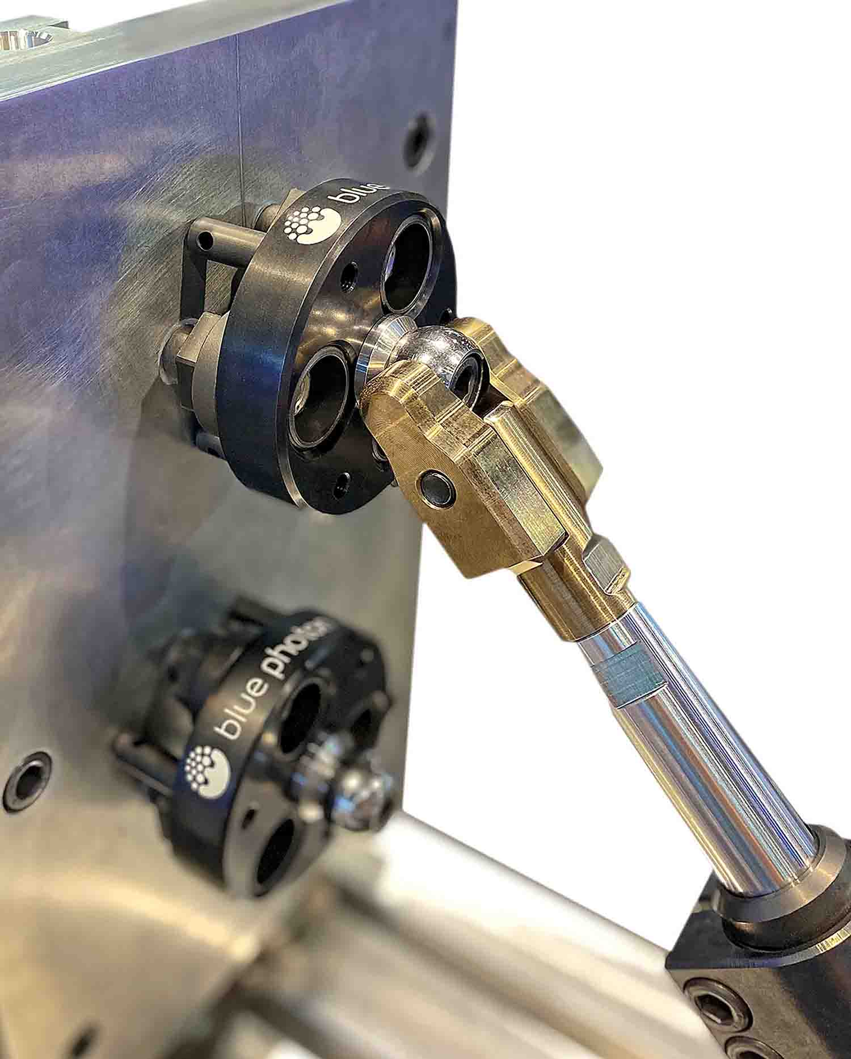

The Blue Photon Workholding Stabilizer System being used with third-party stabiliser equipment for adding extra rigidity to tall components while they are being machined.

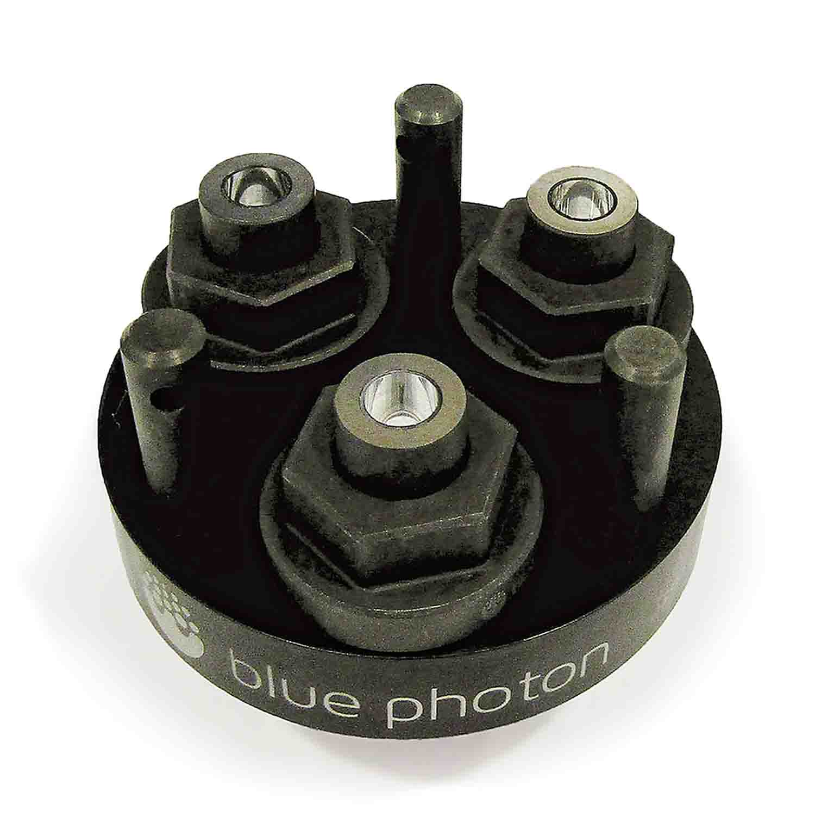

The Blue Photon puck attaches to the workpiece using grippers placed into fixed inserts.

On behalf of: NCMT Limited, Siskin Drive, Middlemarch,
Coventry, CV3 4FJ
Tel: 02476 516600.
E-mail: info@ncmt.co.uk
Web: www.ncmt.co.uk

Issued by: THE RIGHT IMAGE Ltd
PO Box 42, Twickenham, TW1 1BQ
Tel: +44 (0)20 8891 0603
Email: chris@therightimage.net
Web: www.therightimage.net
Contact: Chris Wright

Release no: 1320(EX)

